AMRITA VISHWA VIDYAPEETHAM
CHENNAI

Computer Science and Engineering (CSE)

DESIGN AND ANALYSIS OF ALGORITHMS

Roll No: CH.SC.U4CSE24112
Name: Deepak SN
Class: CSE-B
Year: 2024-2028
Design and Analysis of Algorithms
Job Sequencing:
Code:
#include <stdio.h>
#include <stdlib.h>
#define N 14
struct Job{
int id;
int profit;
int deadline;
};
int compare(const void *a, const void *b){
struct Job *jobA=(struct Job *)a;
struct Job *jobB=(struct Job *)b;
return jobB->profit-jobA->profit;
}
int main(){
int profits[N]={22,19,29,28,30,21,27,25,24,26,14,27,19,11};
int deadlines[N]={3,3,8,6,7,5,10,4,6,12,13,2,14,1};
struct Job jobs[N];
for(int i = 0; i < N; i++){
jobs[i].id=i+1;
jobs[i].profit=profits[i];
jobs[i].deadline=deadlines[i];
}
qsort(jobs,N,sizeof(struct Job),compare);
int maxDeadline=0;
for(int i=0;i<N;i++){
if(jobs[i].deadline>maxDeadline)
maxDeadline=jobs[i].deadline;
}
int slot[maxDeadline+1];
for (int i=0;i<=maxDeadline;i++)
slot[i]=-1;
int totalProfit=0;
for (int i=0;i<N;i++){
for (int j=jobs[i].deadline;j>0;j--){
if(slot[j]==-1){
slot[j]=jobs[i].id;
totalProfit+=jobs[i].profit;
break;
}
}
}
printf("Scheduled Jobs:\n");
for (int i=1;i<=maxDeadline;i++){
if (slot[i]!=-1)
printf("Time Slot %d -> Job %d\n", i, slot[i]);
}
printf("\nTotal Profit = %d\n", totalProfit);
return 0;
}
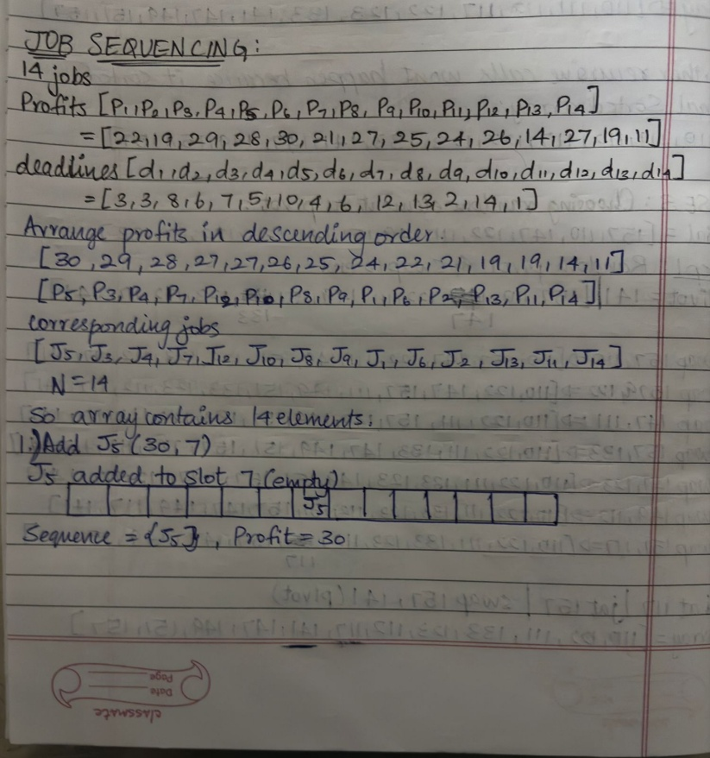
Working:
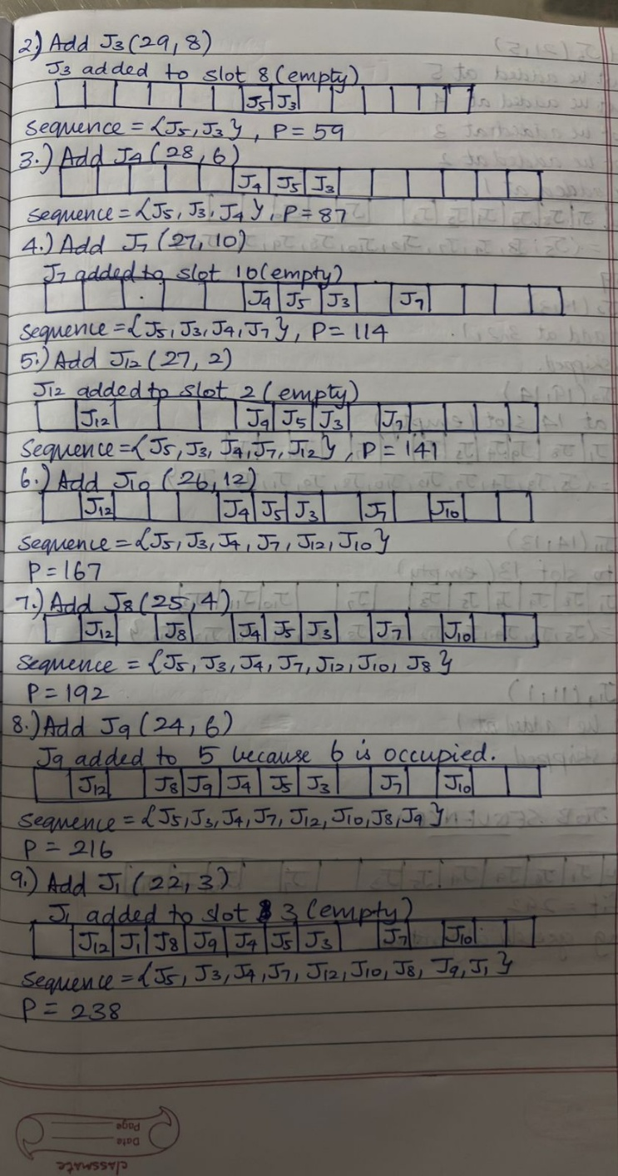

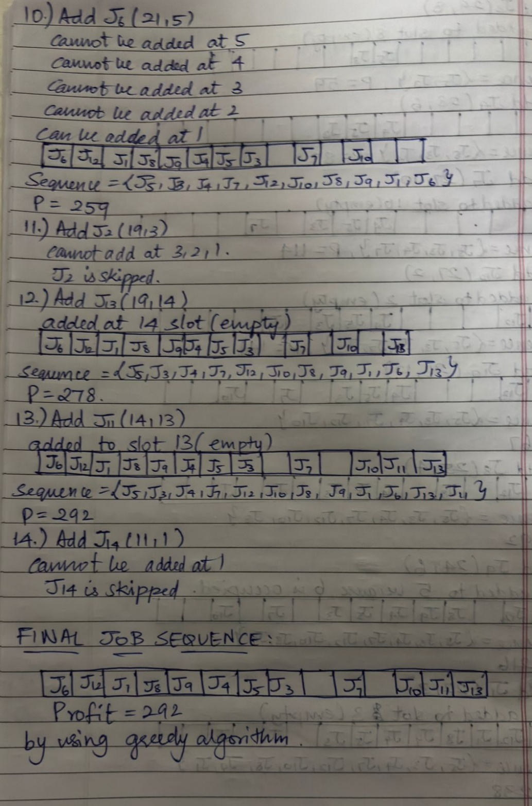

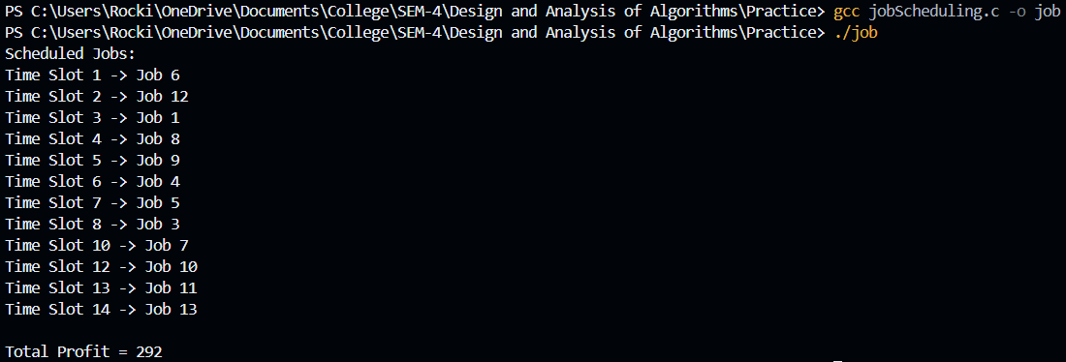
Output:

